K8s Installation -Amazon Linux Server (sudo su -)

**Create a instance**

**AMI- amazon**

**CPU – t2-medium (Very Imp)**

**PPK – private key**

**SG – ALL**

**User- ec2-user for login**

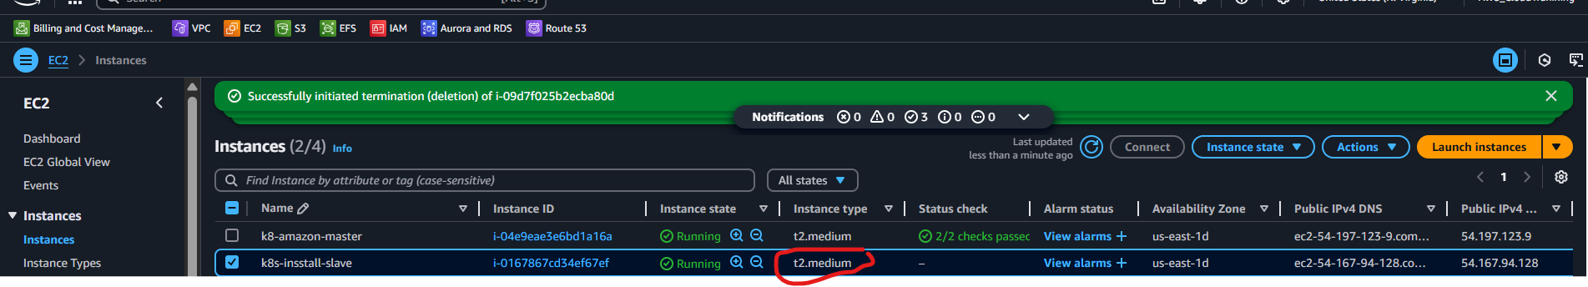

**Use putty Terminal for config – UserID – ec2-user (DATA) and Session Key- PPK in Auth**

**Enter the name & Save it after config (ip, data, auth) – It is saved as “Enter name”**

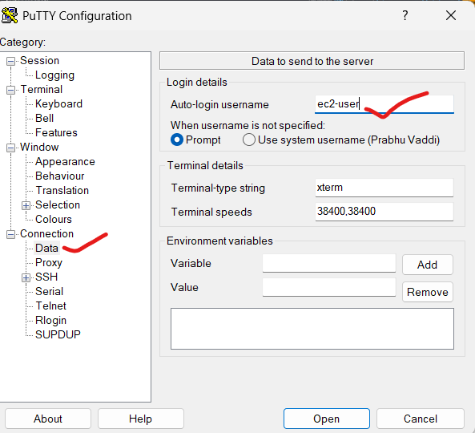

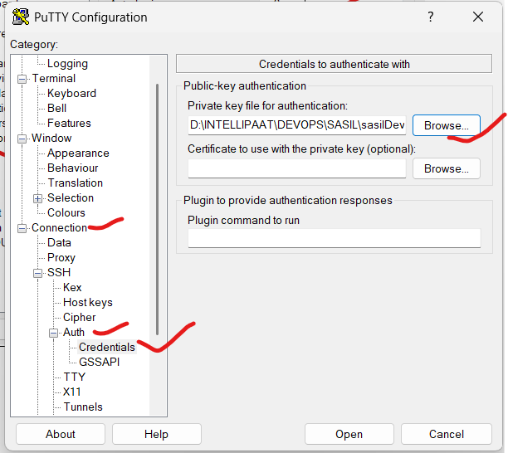

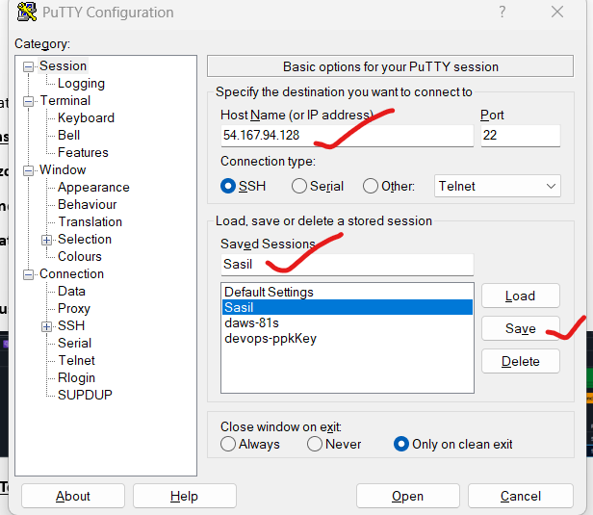

**If you want to generate & save the PPK key on your own. Use – puttykeygen tool**

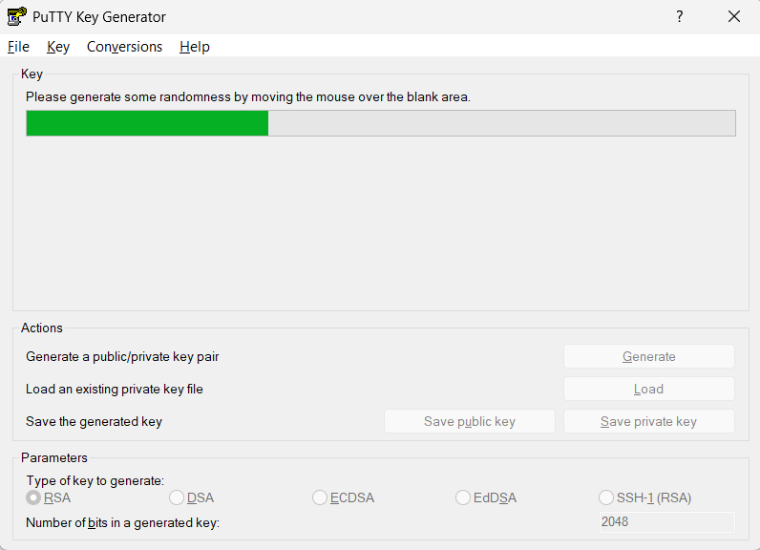

**Commands for installation**

1. hostnamectl set-hostname master

2. setenforce 0

3. clear

4. swapoff -a

5. yum install containerd -y

6. cat <<EOF | tee /etc/modules-load.d/containerd.conf

overlay

br_netfilter

EOF

7. modprobe overlay && modprobe br_netfilter

8. containerd config default | sudo tee /etc/containerd/config.toml

9. vi /etc/containerd/config.toml

10. systemctl start containerd

11. systemctl enable containerd

12. systemctl status containerd

13. cat <<EOF > /etc/yum.repos.d/kubernetes.repo

[kubernetes]

name=Kubernetes

#baseurl=https://packages.cloud.google.com/yum/repos/kubernetes-el7-x86_64

baseurl=https://mirrors.aliyun.com/kubernetes/yum/repos/kubernetes-el7-x86_64/

enabled=1

gpgcheck=0

#repo_gpgcheck=1

#gpgkey=https://packages.cloud.google.com/yum/doc/yum-key.gpg https://packages.cloud.google.com/yum/doc/rpm-package-key.gpg

#gpgkey=https://packages.cloud.google.com/yum/doc/yum-key.gpg https://packages.cloud.google.com/yum/doc/rpm-package-key.gpg

EOF

14. yum install -y kubelet kubeadm kubectl

15. sysctl -w net.ipv4.ip_forward=1

16. kubeadm init --pod-network-cidr=10.244.0.0/16

17. mkdir -p $HOME/.kube

18. sudo cp -i /etc/kubernetes/admin.conf $HOME/.kube/config

19. chown $(id -u):$(id -g) $HOME/.kube/config

20. kubectl apply -f https://raw.githubusercontent.com/coreos/flannel/master/Documentation/kube-flannel.yml

21. systemctl start kubelet

22. systemctl enable kubelet

23. kubectl get nodes

24. history

**Screenshots**

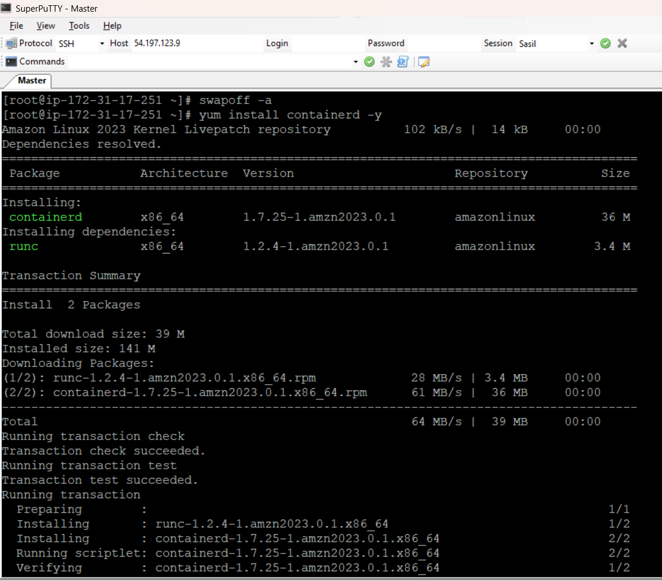

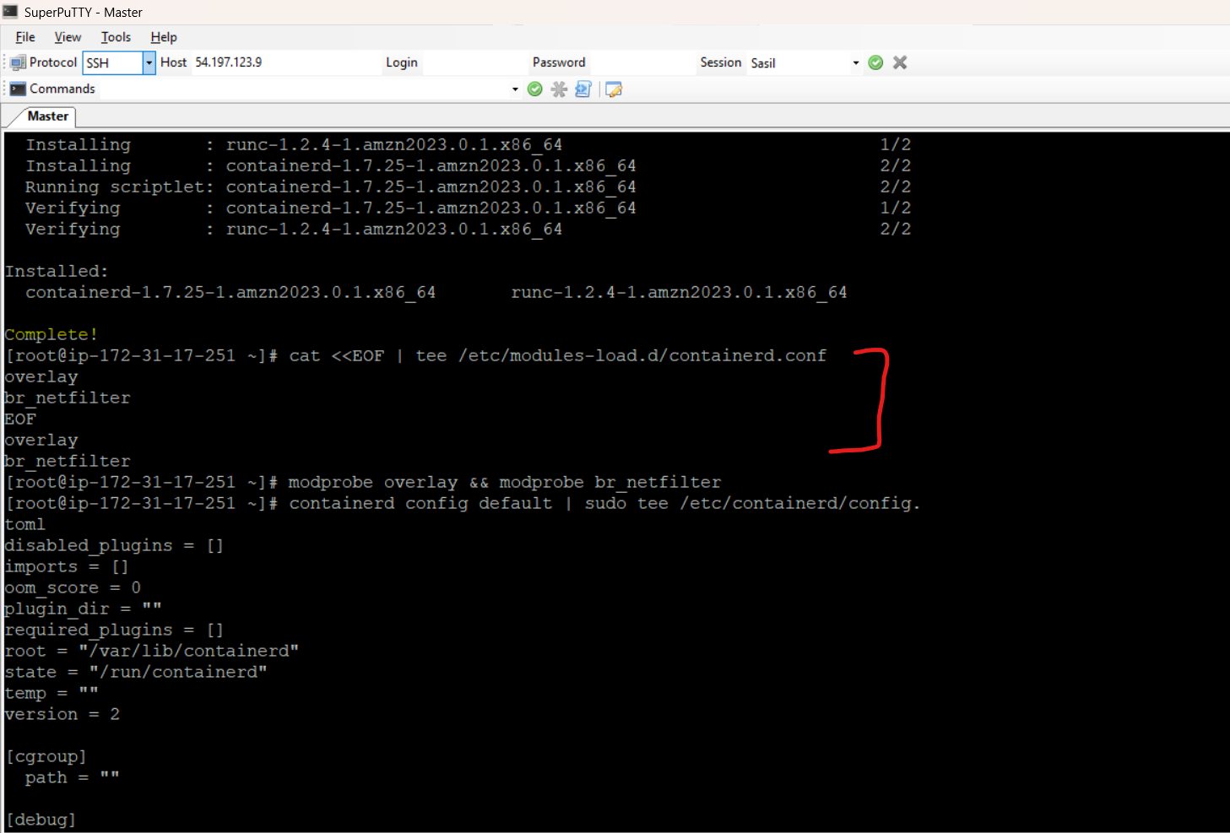

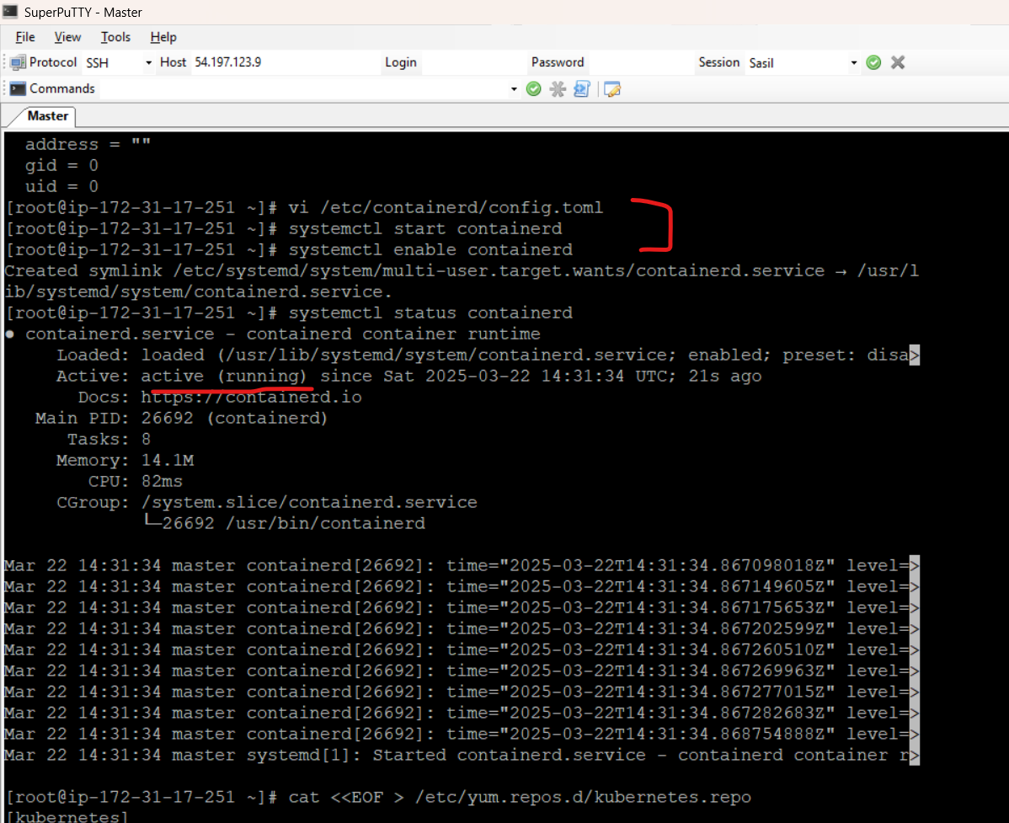

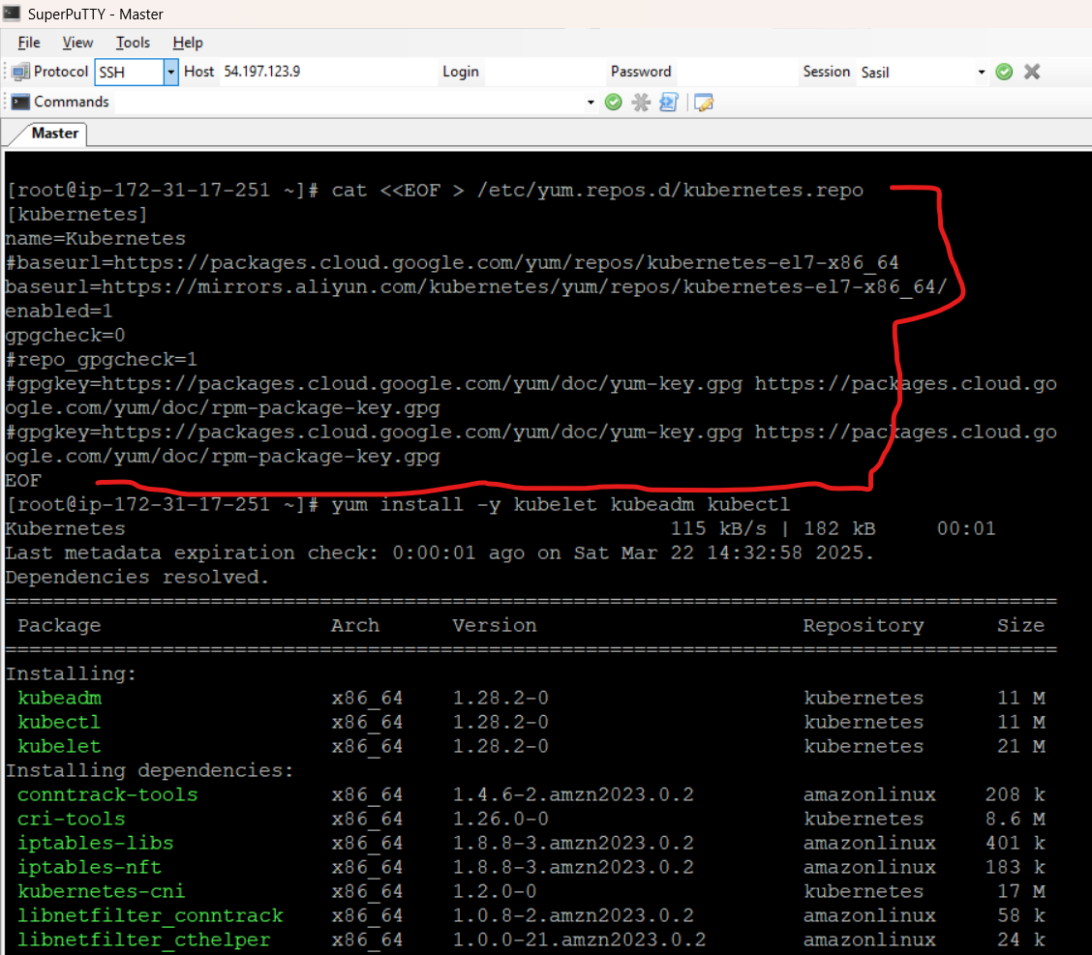

**Install- kubelet**

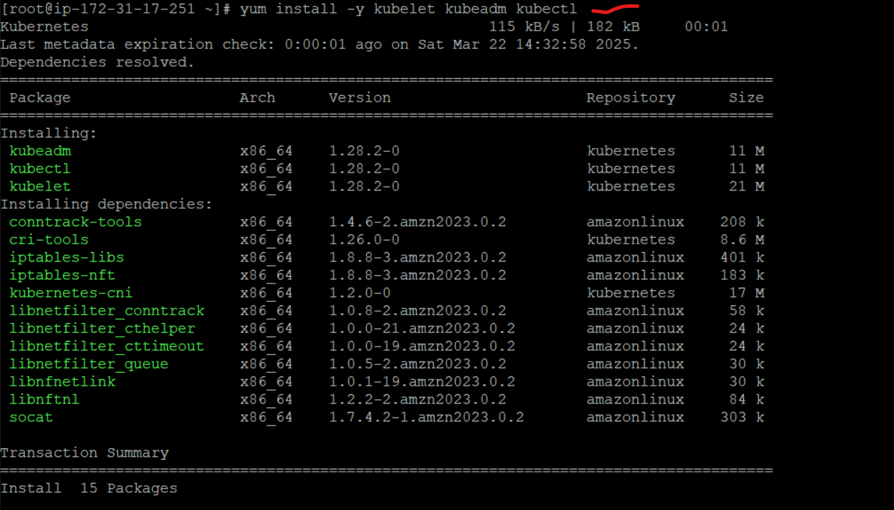

Initialing the network through kubeadm with CIDR - --pod-network-cidr=10.244.0.0/16

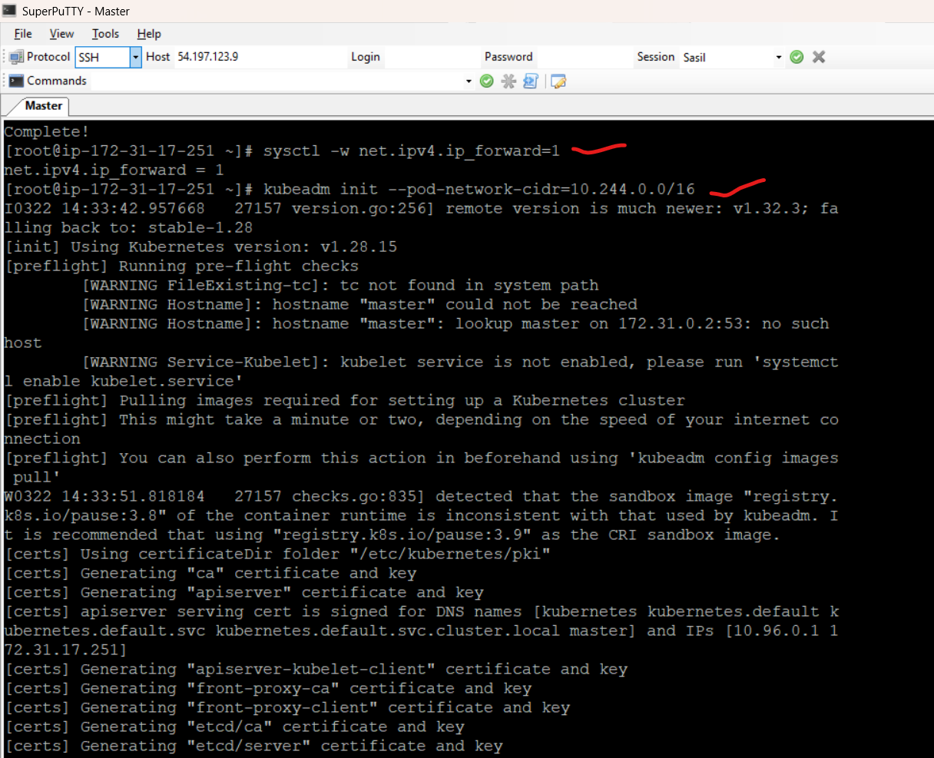

copying admin.config file with .kube hidden directory & applied through kubelet

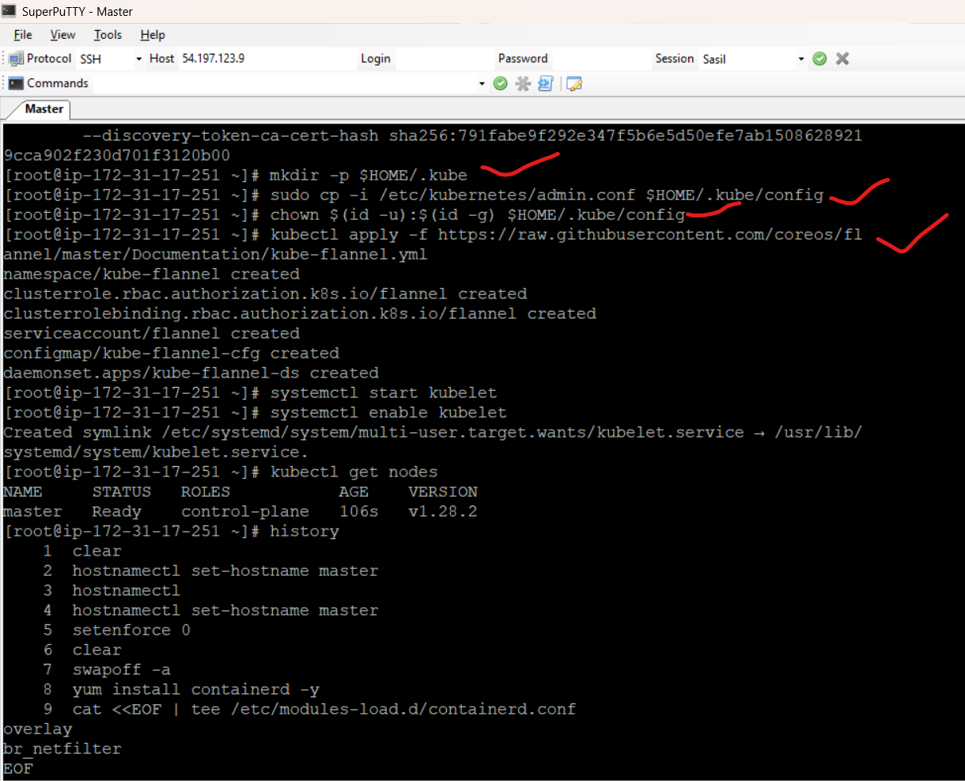

**Restart the session**

1. Sudo su –
2. Kubectl get nodes

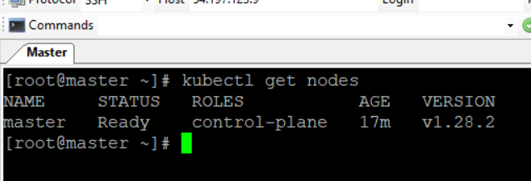

**SLAVE Installation**

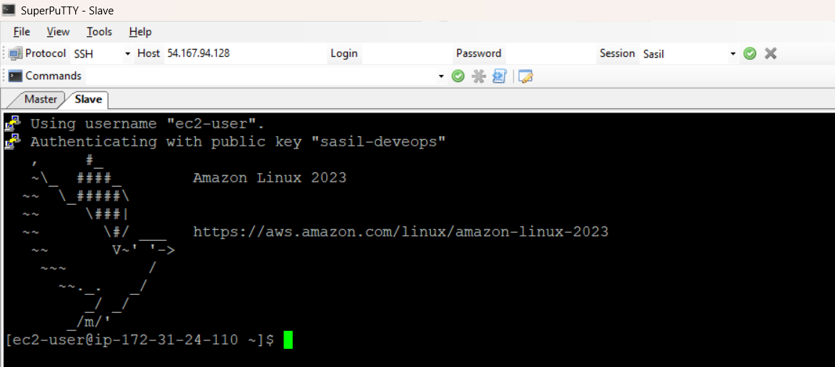

**Follow below commands**

**Checking the existing hostnamectl**

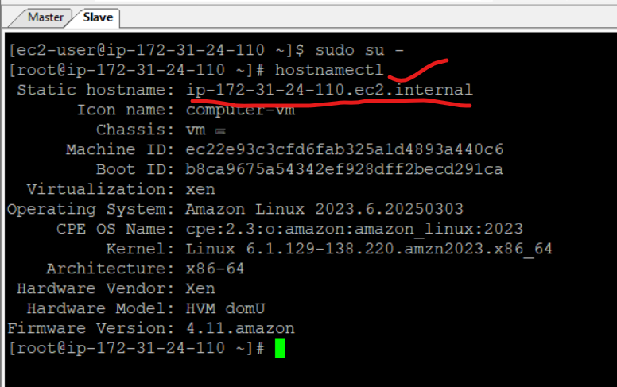

**Imp Thing**

**copy the command similar to below from master, and go to agent and run this step -**

**kubeadm join 172.31.35.132:6443 --token dvssj4.rwkzpq5imcnbbye6 --discovery-token-ca-cert-hash sha256:13c6bb5ec637dde409e328c9e5f677c533d6cfd2ea660f78cd980ddb647d2747**

1. Open master node
2. Create a token link master to slave.
3. kubeadm token create --print-join-command

**Actual value**

kubeadm join 172.31.17.251:6443 --token k6uv8h.o9da8xrotissudrw --discovery-token-ca-cert-hash sha256:791fabe9f292e347f5b6e5d50efe7ab15086289219cca902f230d701f3120b00

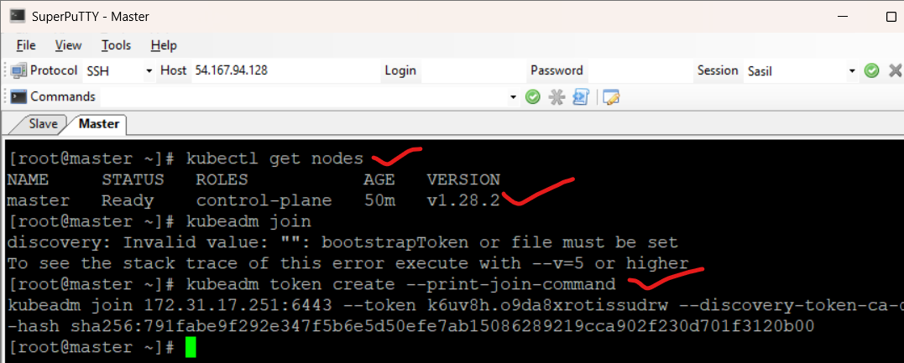

1. Copy & Paste Token from master to agent

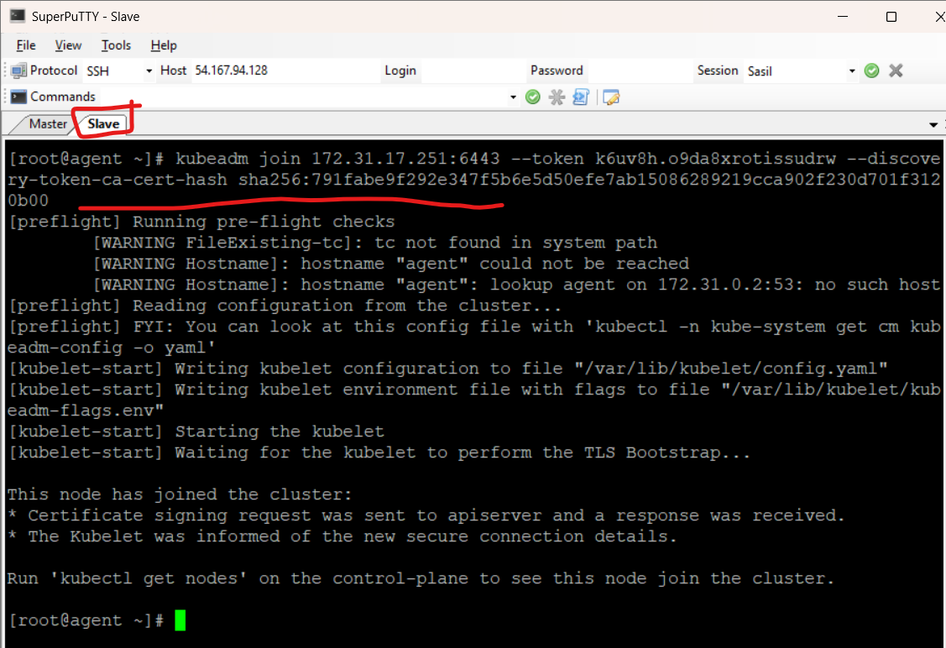

**Master**

After token run below command

Kubectl get nodes. Now, able to see agent token also successfully.

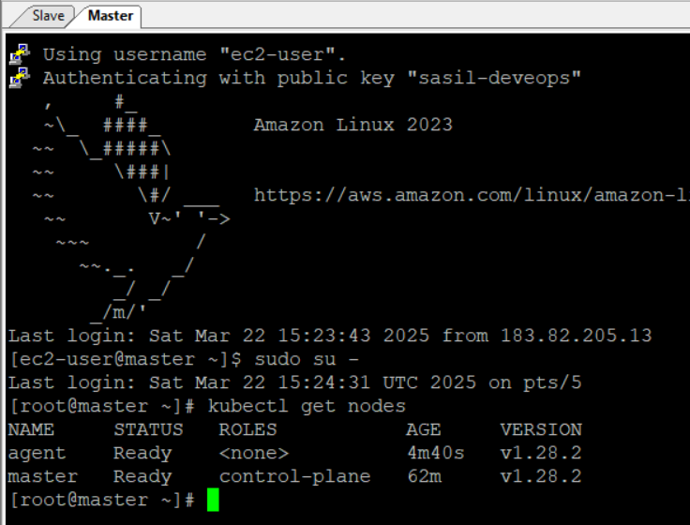

**Ingress Installations**

Git not exists => Install git : yum install git

Reference link for ingress installation - <https://docs.nginx.com/nginx-ingress-controller/installation/installing-nic/installation-with-manifests/>

1. Clone git

git clone [https://github.com/nginx/kubernetes-ingress.git --branch v5.0.0](https://github.com/nginx/kubernetes-ingress.git%20--branch%20v5.0.0)

1. Change directory

cd kubernetes-ingress

1. Follow below steps based on link

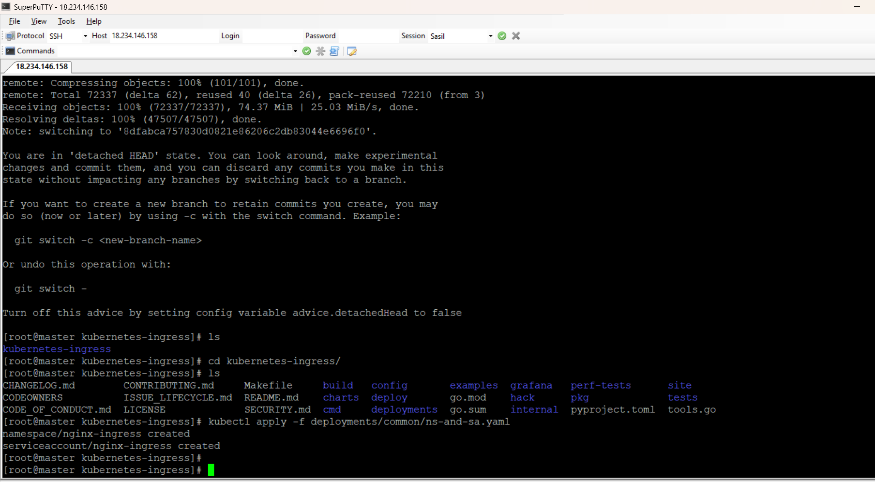

1. kubectl apply -f deployments/rbac/rbac.yaml

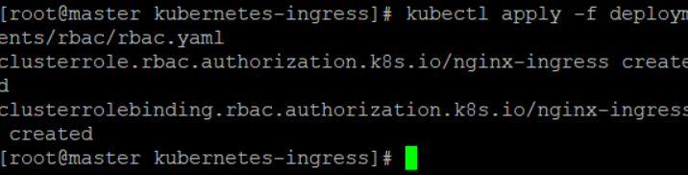

1. Refer below screenshot commands & get ingress data

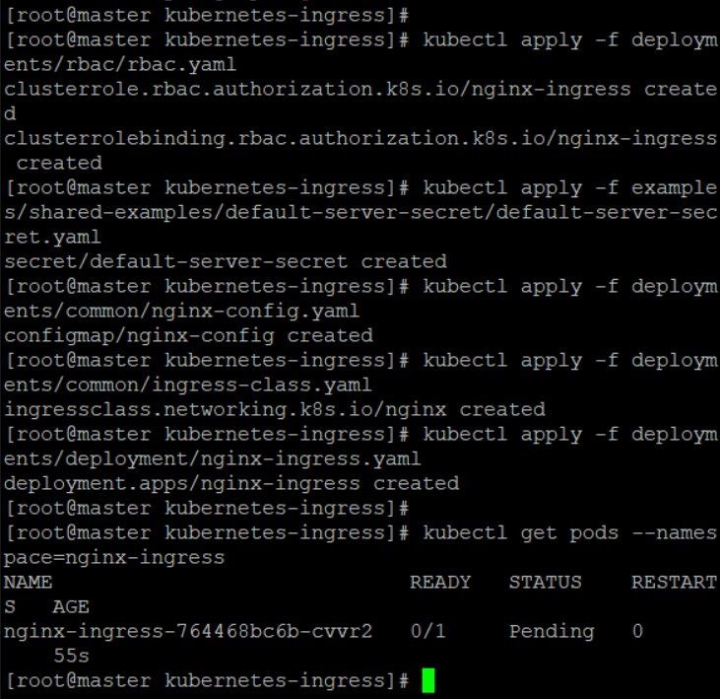

1. Create a service - On-Prem

kubectl create -f deployments/service/nodeport.yaml

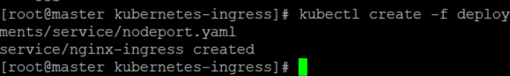

(or)

Optional - If you want service for aws – use command Load Balancer

kubectl apply -f deployments/service/loadbalancer.yaml

1. Get ingress data – nginx-ingress : **SUCCESS**

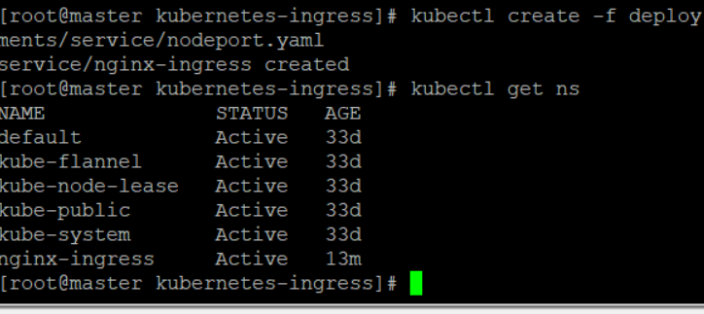

1. **Single Command shows all process – Very Important**

**CMD : kubectl get all -n nginx-ingress [i.e., -n is “NAMESPACE”]**

1. Pods
2. Service
3. Deployment
4. Replica Set

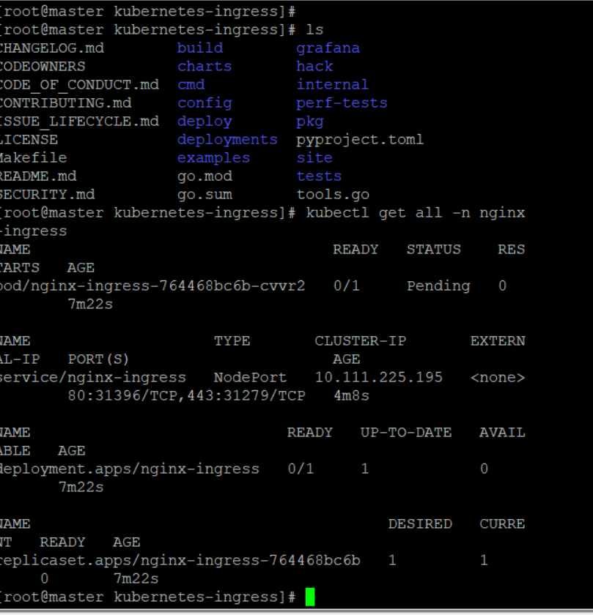

**Note :Ingress has 2 types : 1. Controller – one time activity 2. Ingress rules is a repeated activity**

**Ingress Rule Manifest file**

**Architecure Ingress Controller**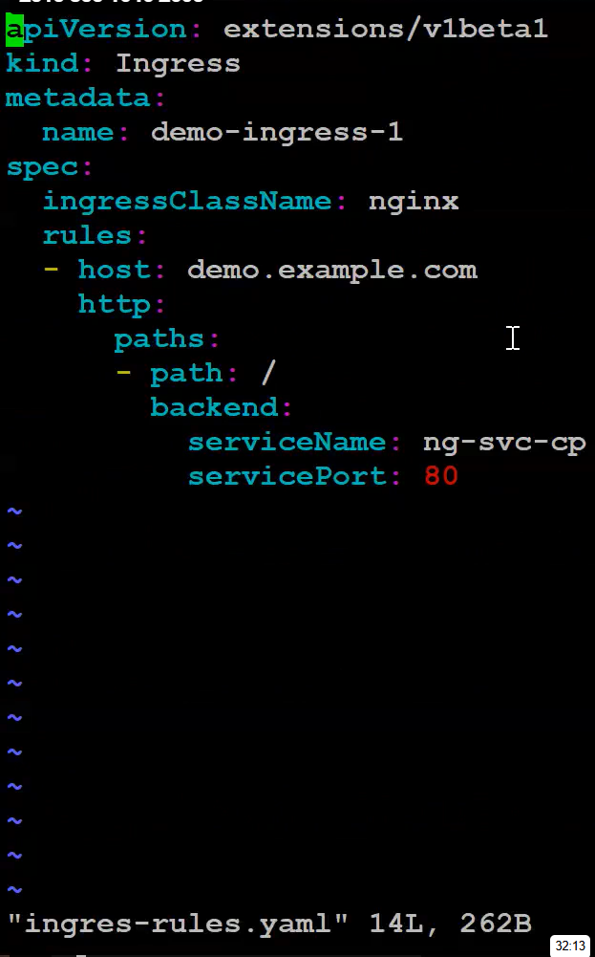

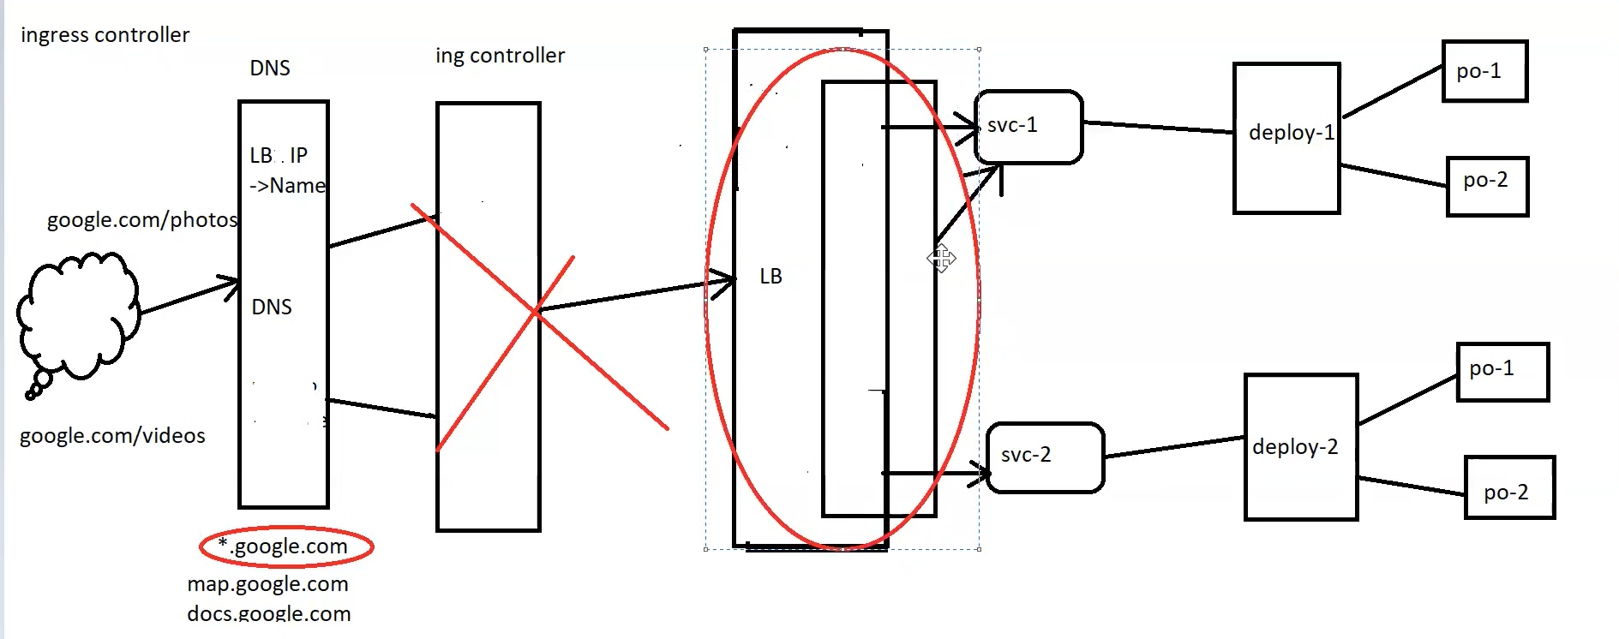

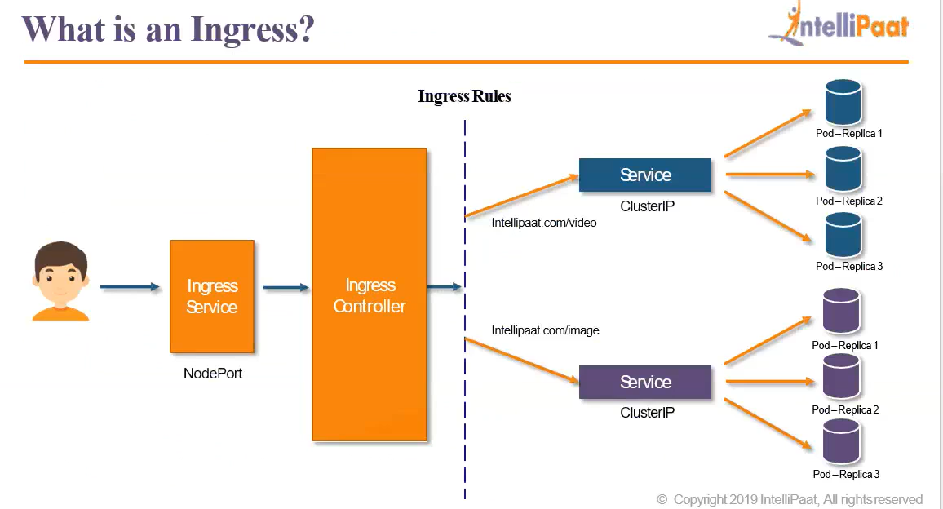

**Dashboard**

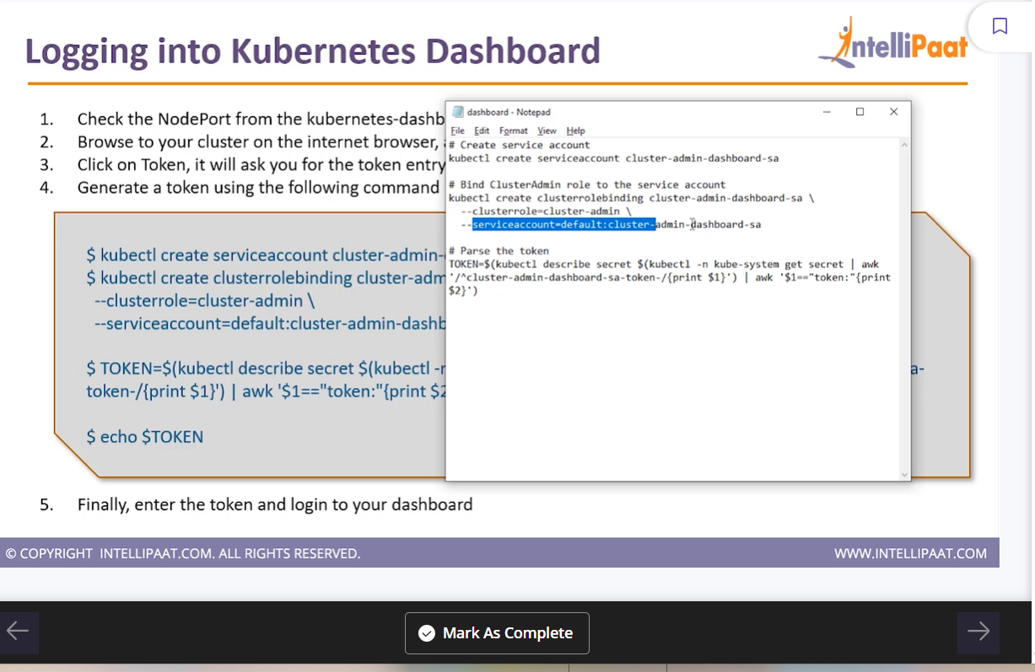**Generate Token and paste in dashboard – able to see ur workloads**

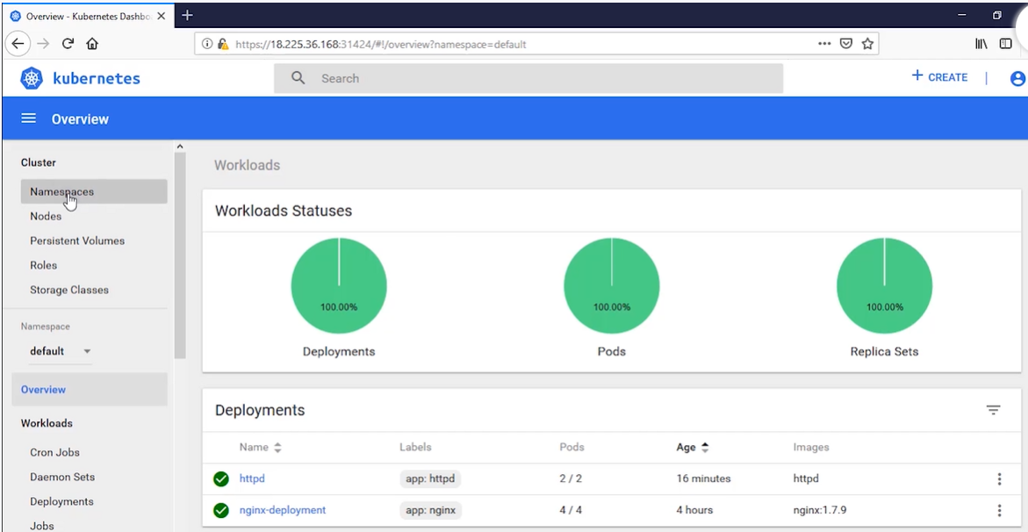

1. **Check pod is running**
2. **Check Service manifest file => target endpoint matches service app to pod endpoint**

**Cmnds**

**Kubectl get po**

**Kubectl get svc**

**Kubectl describe svc ng-svc**

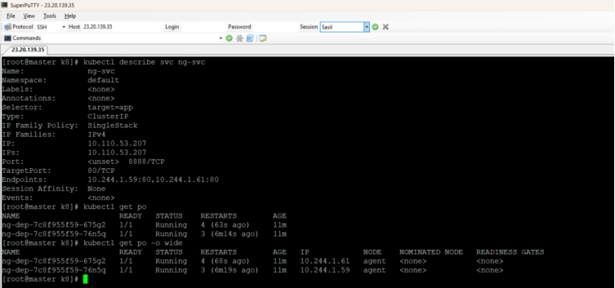

**3.Go inside into the POD**

**Cmd**

**Kubectl exec -it podname –bash**



**Note: If application is not running inside the POD, nothing to works.**

**Public IP for Master & Slave IP With Port are working : Success**

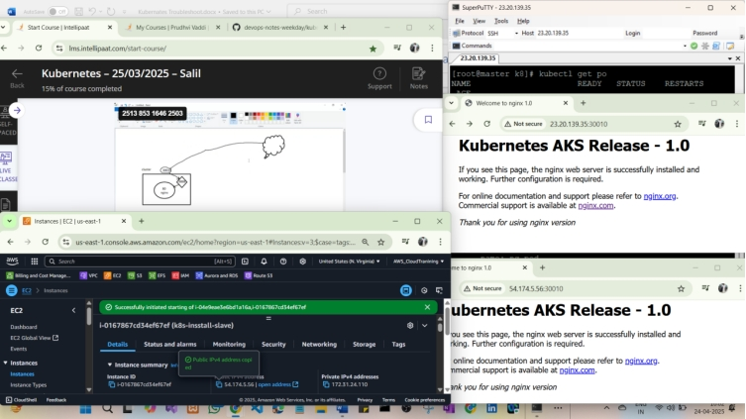

**Storage Manifest File**

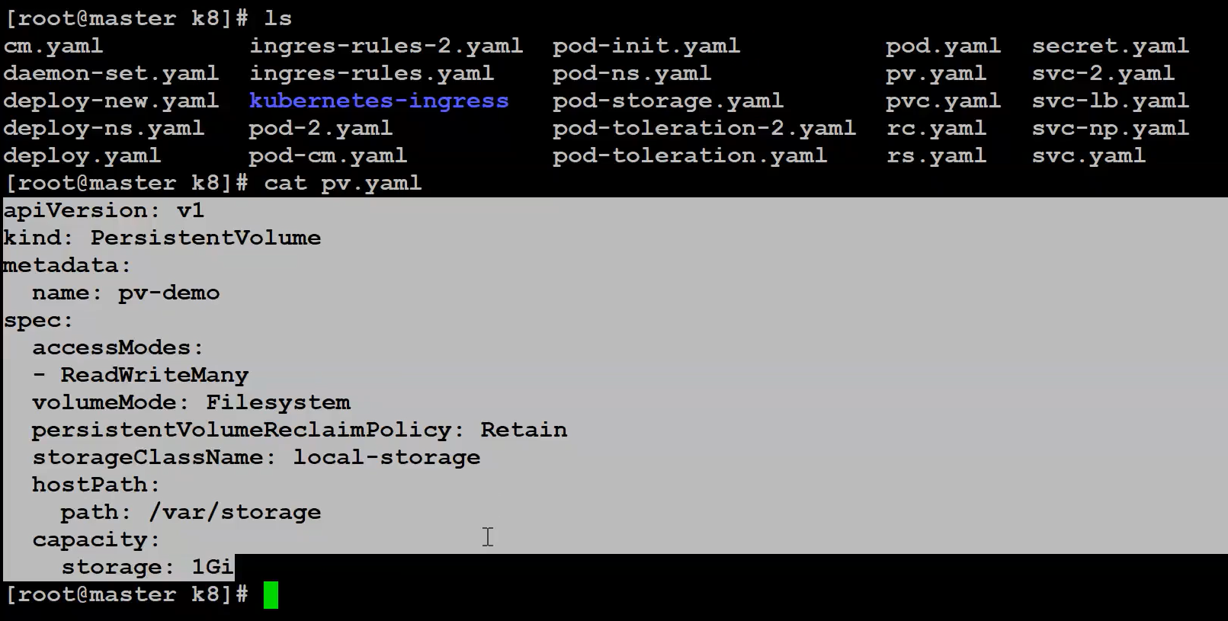

**POD & Volume Manifest File**

